INFO8250 Mobile Application Design(SEC1)

Lab3 Requirements, Design, Documentation

**Name : Hassan Nahhal**

**Sungjoe Kim**

**Nicholas Collins**

**Changho Choi**

# 1. Concepts

This game is mobile application game is a kind of avoid obstacle game. User control the height of plane by controlling the game object to avoid the obstacles and arrive the target place with least amount of bumping at the obstacles. This game will be developed with Android Mobile application platform and Unity 3D engine for rendering and action dynamics characteristics of game objects.

# 2. Target Users

The target user is the instructor for this course(Jean Filion) as he will be the one to evaluate the app that we create. This is a user who is knowledgeable about mobile devices and their uses. The game will be used as part of the evaluation for this class.

# 3. Major Features

1) The game will include a vehicle such as a plane, and obstacles the user can navigate around. Successful navigation without a collision for a longer time will result in a higher score.

2) The player will get more points for continuing longer without hitting any obstacles, and also obtains more points each time a specific obstacle is successfully avoided.

3) If the player bumps obstacles more than a specific number of times, the game will be over.

4) After the game ends, a menu will be shown allowing the user to enter their name and select start over or exit the game.

5) User can destroy the obstacles by shooting which will gain the scores. *(Optional)*

6) Every user’s score will be uploaded at the server, user can confirm their rank. *(Optional)*

# 4. Usecase Diagram

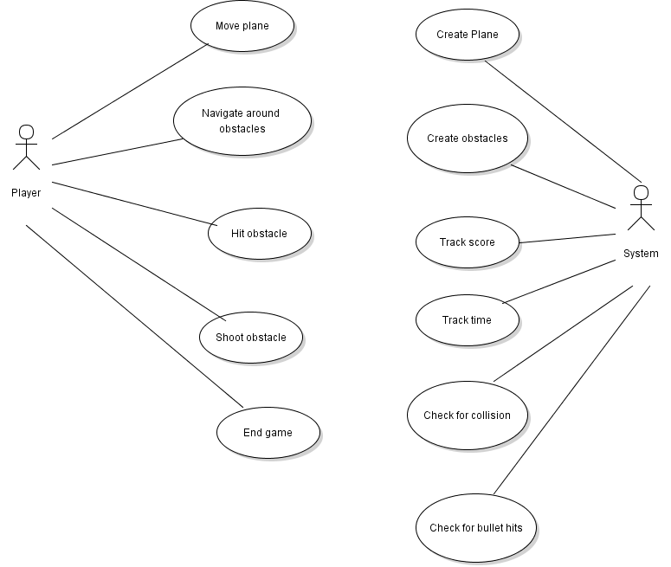

# 5. Sequence Diagram

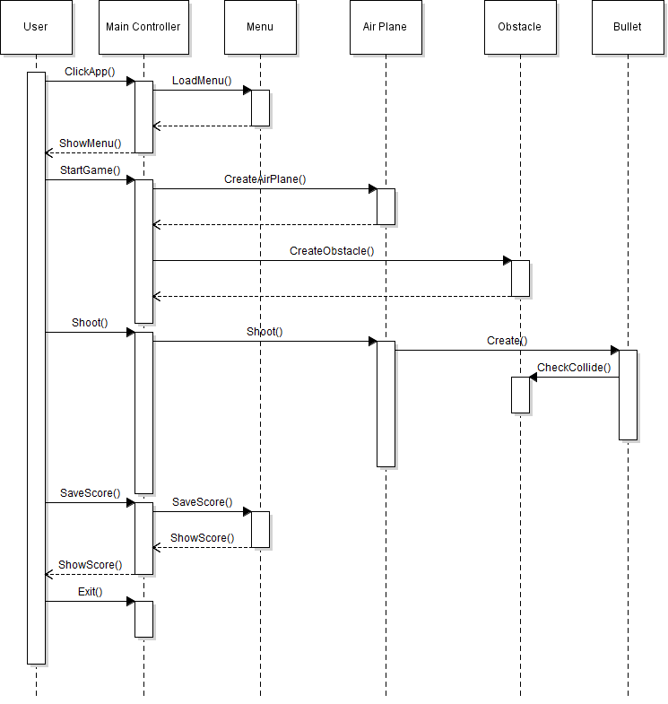

# 6. Class Diagram

